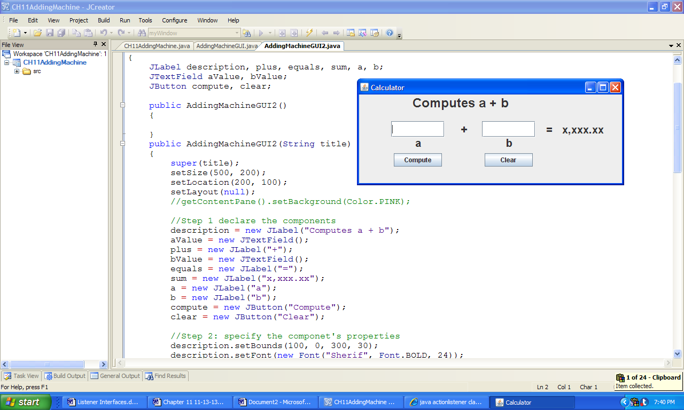

**Figure 11.16 The graphical user interface created by the class AddingMachineGUI.**